While Loop Lab-6

Name: Kaushik Parmar

ID: AF0448761

1. 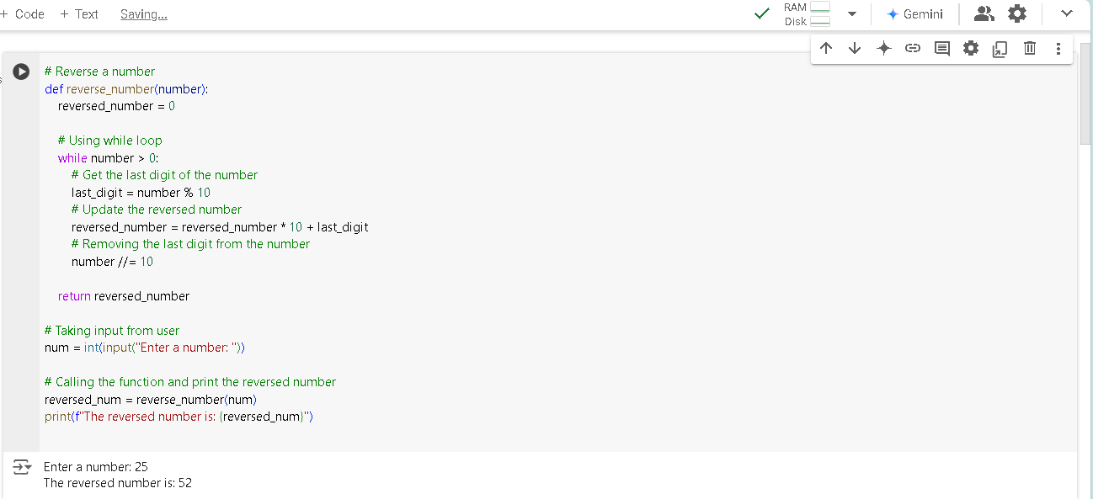Write a python program to reverse a number using a while loop.

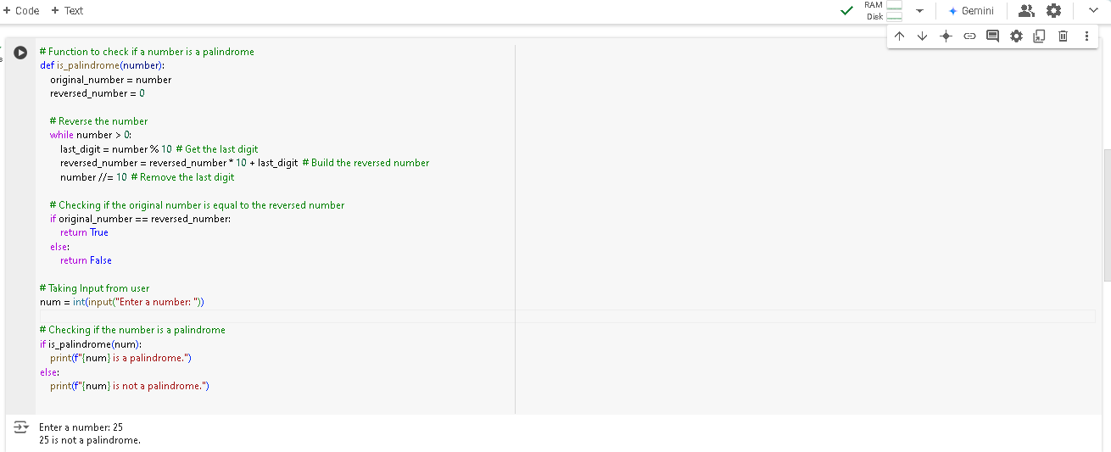 2. Write a python program to check whether a number is palindrome or not?

3. Write a python program finding the factorial of a given number

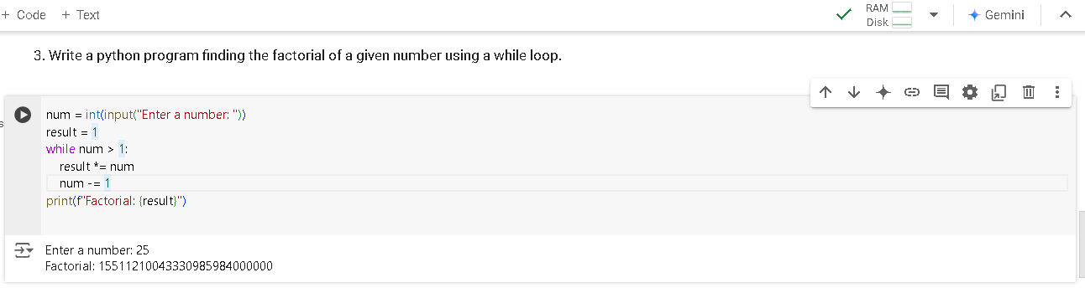using a while loop.

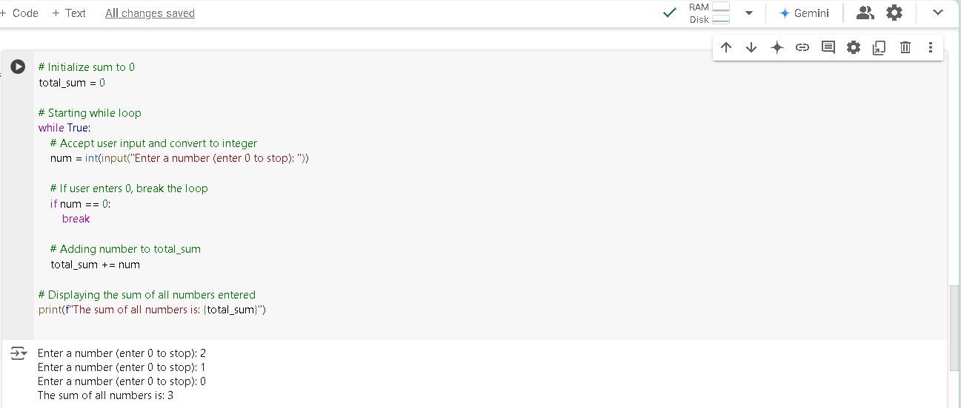4. Accept numbers using input() function until the user enters 0. If user input 0 then break the while loop and display the sum of all the numbers.